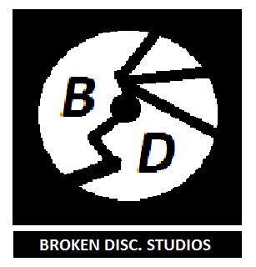

Game Design Document for:

Beat Battle

**The tourney for the magic key**

Stay in tune and beat the treble!

All work Copyright ©2018 by Broken Disc Studios

Written by Michael Caissie & Nichole Lischynski

Version # 1.0

Friday, November 2, 2018

**Table of Contents**

**Beat Battle**

# **D**esign Histo**ry**……………………………………………………………………………………………………………………………………………………………….. 4 Version 1.10…………………………………………………………………………………………………………………………………………………………………. .. 4

Version 2.00…………………………………………………………………………………………………………………………………………………… …………….4

Version 2.10…………………………………………………………………………………………………………………………………………………….. ……..…... 4

**Game Overview** ………………………………………………………………………………………………………………………………………………………………. **5**

Philosophy……………………………………………………………………………………………………………………………………………………….…………... 5

Frequently Asked Questions (FAQ).…………………………………………………………………………………………………………. …………... 5

*What is the game?*………………………………………………………………………………………………………………………………………………………..*5*

*Why create this game?*………………………………………………………………………………………………………………………………………..……  *5*

*Where does the game take place?*…………………………………………………………………………………………………………………...……… *5*

*What do I control?*……………………………………………………………………………………………………………………………………………………  *5*

*How many characters do I control?*………………………………………………………………………………………………………..…………… *6*

*What is the main focus?*………………………………………………………………………………………………………………………………………..… *6*

*What’s different?*……………………………………………………………………………………………………………………………………………..……… *6*

**Feature Set**………………..…………………………………………………………………………………………………………………………………………..……… **7**

General Features………………………………………………………………………………………………..……………………………………………..……… . 7

Multiplayer Features………………………………………………………………………………………………………………………………………..……… 7

Gameplay………………………………………………………………………………………………………………………………………...…………………..…….… 7

**The Game World**………………………………………………………………………………………………………………………………………..…………..……… **8**

Overview…………………………………………………………………………………………………………………………………………………..…………..……… 8

World Feature …………………………………………………………………………………………………………………………….……………………..……… 8

The Physical World……………………………………………………………………………………………………………….………………………..……….. 8

*Overview*…………………………………………………………………………………………………………………………………………………..………..……… *8*

*Key Locations*……………………………………………………………………………………………………………………………………...……………..……… *8*

*Travel*………………………………………………………………………………………………………………………………………………………………....……… *9*

*Scale*…………………………………………………………………………………………………………………………………………………………………....……… *9*

*Weather*…………………………………………………………………………………………………………………………………………………...………..……… *9*

*Day and Night*…………………………………………………………………………………………………………………………………...……………..……… *9*

*Time*……………………………………………………………………………………………………………………………………………………………………..……… *9*

Rendering System……………………………………………………………………………………………………………………….……………………..……… 9

*Overview*………………………………………………………………………………………………………………………………………………….………..……… 9

*2D/3D Rendering*………………………………………………………………………………………………………………………….………………….……… 9

Camera…………………………………………………………………………………………………………………………………………………………….…..……… 9

*Overview*…………………………………………………………………………………………………………………………………………………….……..……… 9

*Camera Detail*……………………………………………………………………………………………………………………………………….………..……… 10

Game Engine……………………………………………………………………………………………………………………………………………….……..……… 10

*Overview*……………………………………………………………………………………………………………………………………………….………...……… *10*

*Game Engine Detail*……………………………………………………………………………………………………………………………….………..……… *10*

*Water*……………………………………………………………………………………………………………………………………………..…………………...…… *10*

*Collision Detection*……………………………………………………………………………………………………………………………………..……… … *10*

Lighting Models………………………………………………………………………………………………………………………………………..……..……… 10

*Overview*……………………………………………………………………………………………………………………………………………..……………..……  *10*

**The World Layout** ……………………………………………………………………………………………………………………………………………...……… **11**

Overview………………………………………………………………………………………………………………………………………………………….....……… 11

World Layout Detail………………………………………………………………………………………………………………………………………..……… 11

**Game Characters**…………………………………………………………………………………………………………………………………..…………..……… **12**

Overview…………………………………………………………………………………………………………………………………………………………....……… 12

Main Characters……………………………………………………………………………………………………………………………….……………..……… 12

Enemies and Rivals……………………………………………………………………………………………………………………………….………….……… 12

Creating a Character…………………………………………………………………………………………………………………………….………..……… 13

**User Interface**…………………………………………………………………………………………………………………………………………..………..……… **14**

Overview…………………………………………………………………………………………………………………………………………………………....……… 14

User Interface Detail………………………………………………………………………………………………………………………….…………..……… 14

**Weapons**……………………………………………………………………………………………………………………………………………..…………………..…… **15**

Overview…………………………………………………………………………………………………………………………………………………………….……… 15

Weapons Detail…………………………………………………………………………………………………………………………………………….....……… 15

**Musical Scores and Sound Effects** ……………………………………………………………………………………………………….……..……… **16**

Overview……………………………………………………………………………………………………………………………………………………….…….……… 16

Background Music (BM) Within the Game………………………………………………………………………………………………..……… 16

Sound Effects (SE) Within the Game……………………………………………………………………………………………….…………..……… 16

Sound Design………………………………………………………………………………………………………………………………………………..…..……… 16

**Single Player Game** ……………………………………………………………………………………………………………………………….…………..……… **17**

Overview……………………………………………………………………………………………………………………………………………………..……..……… 17

Single Player Game Detail……………………………………………………………………………………………………………………………..……… 17

Story……………………………………………………………………………………………………………………………………………………………….……..……… 17

Hours of Gameplay…………………………………………………………………………………………………………………………………………..……… 17

Victory Conditions…………………………………………………………………………………………………………………………………………..……… 17

**Multiplayer Game**……………………………………………………………………………………………………………………….……………………..……… **18**

Overview…………………………………………………………………………………………………………………………………………………..………..……… 18

Max PLayers………………………………………………………………………………………………………………………………………..……………..……… 18

Servers……………………………………………………………………………………………………………………………………….………………………..……… 18

Customization……………………………………………………………………………………………………………………………………...…………..……… 18

Internet……………………………………………………………………………………………………………………………………………………………...……… 18

Persistence……………………………………………………………………………………………………………………………………………..…………...…… 18

Saving and Loading……………………………………………………………………………………………………………………………….………..……… 18

**Character Rendering** ……………………………………………………………………………………………………………………………….……..……… **19**

Overview……………………………………………………………………………………………………………………………………………..………………..…… 19

Character Rendering Detail………………………………………………………………………………………………………………………..….…… 19

**World Editing** …………………………………………………………………………………………………………………………………………………….……… **20**

Overview……………………………………………………………………………………………………………………………………………..…………………..… 20

**Extra Miscellaneous Stuff**……………………………………………………………………………………………………………………………..……… **21**

Overview……………………………………………………………………………………………………………………………………………………………..……… 21

Extra Content……………………………………………………………………………………………………………………………………………..………….… 21

**“Objects Appendix”** …………………………………………………………………………………………………………………………………………..…..…… **22**

**“Story Appendix”** ……….……………………………………………………………………………………………………………………………………..…..…… **23**

**Design History**

**Version 1.10**

Version 1.10 includes small changes from time to time as the GDD was made.

1. Rival was included
2. New Enemies
3. Edited world layout

**Version 2.00**

Version 2.00 has increased major changes to original plan of game.

1. Added multiplayer
2. Story details
3. Enlarge Tourney size
4. Change of plot line
5. Edited world layout

**Version 2.10**

Version 2.10 has smaller updates to 2.00.

1. Given unique weapons to opponents
2. Multiplayer Character customization
3. Added more opponents
4. New Characters
5. Edited world layout

**Game Overview**

**Philosophy**

What we’re trying to achieve with this title is to add a renewed subgenre into the video game industry. Using a new method of gameplay we hope to bring light to a new subgenre of RPG/rhythm based games.

**Frequently Asked Questions (FAQ)**

**What is the game?**

Our game is a family-friendly rhythmic battle based role-playing game where, like in a rhythm game, you tap notes in a timed fashion, where depending on your accuracy you inflict damage upon your enemy, and, like in a role-playing game, you follow a linear plot and control a preset character as they go head-to-head with their foes during battle. This is a game about strategy, skill, and music.

**Why create this game?**

Our goal was to collaborate with classic gaming mechanics and try to blend them together -- which creates the rhythm rpg genre. Yes, similar projects do exist, but we hope to add our own styles, techniques, and methods to our own game.

**Where does the game take place?**

Our game follows an adventure that rehearses in the fantastic realm of Sinfonia, a prosperous, musically advanced country littered with adept musicians of every profession, physique, and race. Initially you start off in a small homey town called Donbora, but to join the the 100th annual competitive Musical Tournament you take a short journey to Orkesta.

**What do I control?**

In single-player mode the player controls a preset character, an aspiring young violinist named Vio who set out on the most exciting adventure of his life to become *the very best* musician.

In multiplayer mode you continue your personal adventure as the same character initially, but with his name exchanged with one of your choice and with further customizations available to purchase, as will your online competitors.

Altogether, you control navigation in an rpg-esque fashion by using “arrow keys” on the touchscreen, and during battle you tap notes in a times fashion, controlling the damage inflicted on your opponent, and which special attacks or combos are performed in the heat of the fight.

**How many characters do I control?**

In any game mode, the player controls only one character throughout the entirety of the storyline. Customizations can be conducted on the playable character in multiplayer mode, along with an optional name change.

**What is the main focus?**

The game’s main focus is to guide Vio to the climax of the Musical Tournament to achieve entitlement as *the very best* musician in all of Sinfonia -- well, at least out of those who competed. The end of the tournament awards the winner the Note Key -- a legendary artifact that unlocks the online tournament in multiplayer mode. The only obstacle you have to hurdle, a crescendo of opponents desperate and determined to get in the way.

**What’s different?**

Typically, rhythm based games, including hybrid RPGs, adopt the *Guitar Hero* style of gameplay. Our game, rather than having adjacent spaces to hit incoming notes at the bottom or side of the screen, executes its gameplay in a lesser common fashion where the notes appear in assigned spots on the screen for the player to tap. Also unlike some *Guitar Hero*-like games, our game is complete with an original soundtrack. Furthermore, instead of having and increasing permanent stats like one would in a common roleplaying game like *Dungeons and Dragons*, you can gather upgrades or statis potions -- purchasable with battle points earned after each battle -- that affect your stats; speed, attack, and defence, temporarily.

**Feature Set**

**General Features**

* Abundance of musicians.
* Completely original artwork.
* Completely original soundtrack.
* Unlockable music.
* Puns. So many Puns. (e.g. Live Beet… hoven, Treble Trouble)

**Multiplayer Features**

* Customizations including character skins, instrument skins, and an optional name change.
* Random matchup match for two online players.
* Unlockable tournament competition.
* 24 players per tournament.
* 48 players per team-tournament.

**Gameplay**

* Action battle system.
* Music based battle.
* Powerups and rewards.
* Test of physical coordination.
* Test of timing and accuracy.

**The Game World**

**Overview**

Sinfonia is a prosperous, musically advanced country littered with adept musicians of a diverse profession, physique, and race. The capital of Sinfonia is Orkestra, coincidentally where the Annual Music Tournament takes place each year. Among the numerous musically-inclined municipality, there is one town that banned music altogether for undisclosed reasons; Atsedena.

**World Features**

**The 100th Annual Music Tournament**

The 100th annual Music Tournament has begun and our hero has taken it upon himself to take part. The music tournament is held every year and today is it’s hundredth celebration and musicians from around the world have come to take part. Music, games and venders what every good event needs, but there is something going on under everyone's noses the tourney has an evil looming over it. This competition attracts countless ambitious and enterprising individuals to gather and brawl head-to-head in musical combat. Those incapacitated and known to forgo will forfeit in ignominy. Meanwhile, those virtuoso who remain strong-willed and ignited will rise to the unparalleled opportunity to compete. The upcoming year, the 100th anniversary of the first competition, promises the victor the legendary Notekey; a relic said to unlock the unknown potential of another world.

**The Physical World**

**Overview**

Sinfonia the musical country built up with small towns surrounding the capital city Orkestra. Music can be heard from all over coming from each individual town except one. The people are happy and the world is bright for the most part.

**Key Locations**

* Denbora is a small residential town where the main protagonist originates.
* Orkestra resides as the capital of Sinfonia. It’s a beautiful, flourishing community with a highly vigorous economy. Its inhabitants are musicians of all natures, and the Music Tournament is held here annually.
* Astedena is a poky town against music, the only one of its kind in the country of Sinfonia. The hometown of the main protagonists’ rival.

**Travel**

Since Sinfonia isn’t technically advanced so to get from place to place residents must either walk, carpool a horse-drawn carriage, or they somehow manage to learn to fly.

**Scale**

The world is scaled to a real life country although the character never leaves his main path to travel between his town and the capital the entirety of the game majorly resides within the capital city.

**Weather**

Generally always bright and sunny. There will be no weather system in the game.

**Day and Night**

The game will have no day or night system but its assumed that the realm of Sinfonia has a typical day and night occurrence.

**Time**

Loading screens will feature a timer that says [blank] beats later. (e.g. 24 Beats Later…)

# **Rendering System**

**Overview**

The rendering system is simple, considering this is a mobile game that’s partially art-based.

**2D/3D Rendering**

2D rendering that is limited to shadows and screen alterations like shaking.

# **Camera**

**Overview**

The camera will follow the player in third-person perspective. Cutscene will have a visual novel style display, so the camera will remain above the map.

**Camera Detail**

Once a character interacts with another person a chat box appears at the bottom of the screen. The characters full art then appears above the chat box. The characters full art would become more pronounced, like a camera focusing on a character in the foreground rather than the background, to represent who is speaking inside the chat box.

# **Game Engine**

**Overview**

Unity will be used to create the game.

**Game Engine Detail**

Unity can create games for over twenty-four gaming platforms in both 2D and 3D. Unity is very well-recognized. It supports C# and API scripting and promotes bump mapping, reflection mapping, parallax mapping, screen space ambient occlusion, dynamic shadows using shadow maps, render-to-texture and full-screen post-processing effects as well as custom vertexes, fragments, tessellation, and compute shaders.

**Water**

The game has no water areas planned at this given time.

**Collision Detection**

If the player were to run their character into a wall they will not go through. The game will handle collision detection well, hopefully using the priori method.

**Lighting Effects**

**Overview**

The game is art based, so most lighting effects will be drawn onto maps. No lighting model is necessary.

**The World Layout**

**Overview**

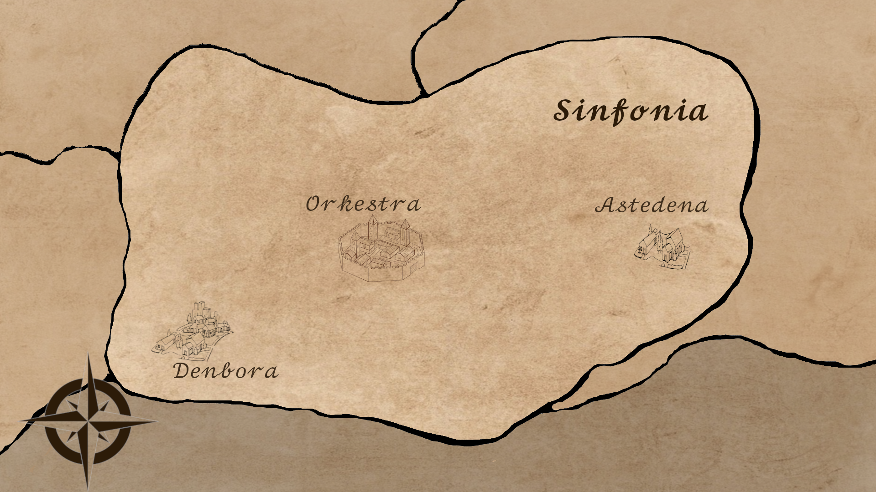

(First version map of Sinfonia. More to be added.)

**World Layout Detail**

The two major areas in our game, in the country of Sinfonia, are Orkestra and Denbora. Denbora is the starter city and is exclusive the opening cutscenes at the beginning of the game. Orkestra is where the majority of the game takes place as it is where the annual Musical Tournament is held.

**Game Characters**

**Overview**

Most characters consist of brawlers in the Music Tournament who will battle against the player as they proceed through the main story. The character creation doesn't exist initially and is unlockable for multiplayer mode.

**Main Characters**

**Vio**

A contendant in the 100th Annual Music Tournament. Main protagonist and the rival/childhood friends with Shadow. On a journey to be *the very best* musician in all of Sinfonia.The character creation system only exists in multiplayer mode.

**Enemies and Rivals**

**Shadow**

A contendant in the 100th Annual Music Tournament. Vio’s rival and childhood friend who lives in the infamous Astedena.

**Maraca Master (Tournament Host)**

Host in the 100th Annual Music Tournament. Final boss.

**Bango Bender**

A contendant in the 100th Annual Music Tournament.

**Bongo Breaker**

A contendant in the 100th Annual Music Tournament.

**Fluttle**

A contendant in the 100th Annual Music Tournament.

**Live Beat… (hoven)**

A contendant in the 100th Annual Music Tournament.

**The Notetaker**

A contendant in the 100th Annual Music Tournament. Kidnaps Vio and other contestants out of pure jealousy when he’s disqualified from the competition so early.

**Sexy Sax**

A contendant in the 100th Annual Music Tournament.

**Treble Trouble**

A contendant in the 100th Annual Music Tournament.

**Triumphant Trumpet**

A contendant in the 100th Annual Music Tournament.

**Ukulele Hero**

A contendant in the 100th Annual Music Tournament.

**Violent Violinist**

A contendant in the 100th Annual Music Tournament. Has an uncanny resemblance to Vio, except… darker and more muscular.

**The REST of ‘em**

A contendant in the 100th Annual Music Tournament.

**Creating a Character**

There is no legitimate character creation system. However, in multiplayer mode there are character customizations, purchasable with BP (Battle Points earned after each battle), including character skins, instrument skins, stat changes, and an optional name change.

**User Interface**

**Overview**

The User interface or UI will consist of an inventory, Attack screen, chests, Pause menu, Battle Screen and Start screen. Anything the user can interact with that's not the controls of the character.

**User Interface Detail**

1. **Inventory:** change equipment of character and item use
2. **Battle screen:** the user is able to select items, attack or run
3. **Attack screen:** Select type of attack and click on rhythm bubbles
4. **Chests:** Put or take items in or out of chest inventory
5. **Pause Menu:** allows user to save game, exit game, access settings and resume game
6. **Start Screen:** allows user to Start Game, change settings or exit game.

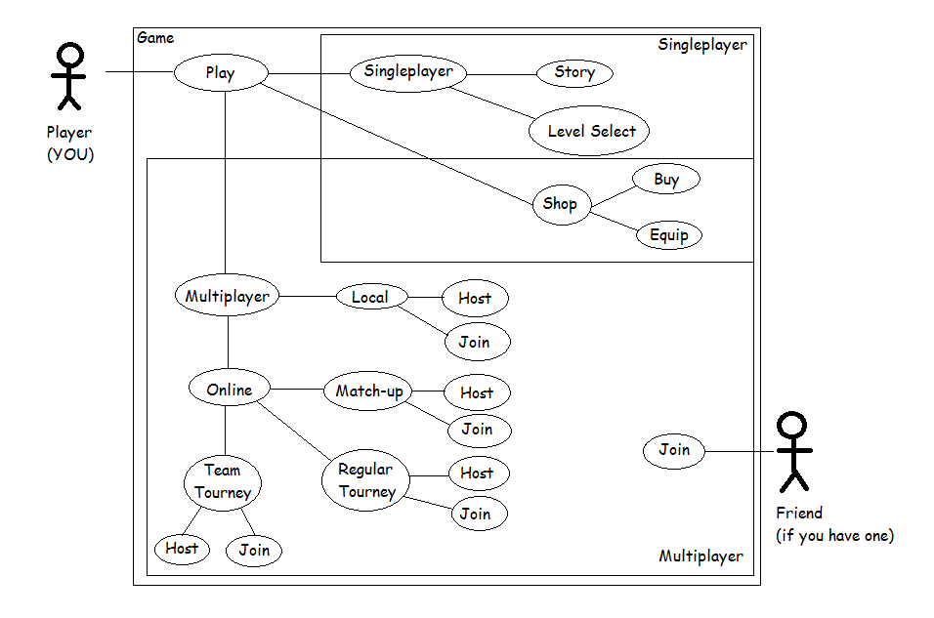

**Weapons**

**Overview**

Even though the entirety of the main storyline is labeled as a brawl there are technically no weapons. Instead, since “the brawl” is a battle of music, contestants in the Music Tournament “battle” with instruments, executing their attacks using rhythm. There are various instruments that can be unlocked with story progression.

**Weapons Detail**

**Vio’s Violin**

The initial weapon of the playable character throughout the main storyline of the game. Can eventually be exchanged with other weapons after the main storyline is beaten and customizations are unlocked.

**Shadow’s Keytar**

A cool weapon used by Shadow throughout the main storyline of the game. Unlockable to purchase with BP in multiplayer mode as a character customization. Increases speed only while equipped.

**Maraca Master’s Maracas**

A pair of maracas possessed by the Maraca Master throughout the main storyline of the game. Unlockable to purchase with BP in multiplayer mode as a character customization. Increases defence only while equipped.

**Violent Violinist’s Violin**

A monochrome violin used by the Violent Violinist throughout the main storyline of the game. Unlockable to purchase with BP in multiplayer mode as a character customization. Increases attack damage only while equipped.

**The Notetaker’s Lyre**

A mysterious lyre used by The Notetaker throughout the main storyline of the game. Unlockable to purchase with BP in multiplayer mode as a character customization. Increases evasion only while equipped.

**The Rest of ‘em’s Triangle**

A boring Triangle that is used by The Rest of ‘em throughout the main storyline of the game. Unlockable to purchase with BP in multiplayer mode as a character customization. Causes confusion on anyone in the arena.

**Musical Scores and Sound Effects**

**Overview**

All music will be original and sound effects will be obtained on royalty free sites. There will be no 3D sound.

**Background Music (BM) Within the Game**

Festival Music

Battle Music

Battle engagement

Attack Music

Shop Music

**Sound Effects (SE) Within the Game**

Chest opening

Doors opening

People talking

Chat scrolling

Tourney trumpet sounds

Cheering

Item usage

**Sound Design**

Battle music will be upbeat, fast-paced, and sanguine music where, when you fight, your attacks match up to the beat, making the rhythm game satisfying to play.

Background music will be bright and catchy, keeping the atmosphere cheerful and fun.

**Single-Player Game**

**Overview**

Single player mode follows the main story of the game. As you progress you can unlock instruments and customizations for online play and practice in practice mode.

**Single-Player Game Detail**

* Linear storyline.
* Preset main playable character.
* Unlockable content, including multiplayer mode and character customizations.
* Practice mode available at all times.

**Story**

Every year Orkestra, capital of Sinfonia, holds the Music Tournament. This competition attracts countless ambitious and enterprising individuals to gather and brawl head-to-head in musical combat. Those incapacitated and known to forgo will forfeit in ignominy. Meanwhile, those virtuoso who remain strong-willed and ignited will rise to the unparalleled opportunity to compete. The upcoming year, the 100th anniversary of the first competition, promises the victor the legendary Notekey; a relic said to unlock the unknown potential of another world. Who could have what it takes to win--

Vio, a young aspiring violinist, is no doubt one of the best musicians in his small hometown of Denbora. With that fact atop his ego, he wants more; to be *the very best* musician in all the world. Knowing of the favored Music Tournament Vio packs his bags and heads to Orkestra.

Upon arrival who should he see signing up at the gates but his childhood friend long since separated, Shadow. After the encounter, Vio knows what’s at stake. This isn’t just a competitive test of skill, but a battle of the century -- a true show to determine who is *the very best* musician.

**Hours of Gameplay**

To complete the main storyline there is an estimated seven hours of gameplay.

**Victory Conditions**

* To beat the game the player must complete the main storyline.
* To beat each battle the player must knockout (KO) their opponent.

**Multiplayer Game**

**Overview**

Optional local or online play in random match-up mode, and online play in customizable regular or team-tournament modes. Altogether, the maximum amount of players you can have on one server at a time is forty-eight.

**Max Players**

* 2 players maximum per random match-up.
* 24 player maximum per every regular tournament.
* 48 player maximum per every team-tournament.

**Servers**

The servers are optional; peer-to-peer to play local with your friends or client server to battle against those around the world.

**Customization**

* The playable character and their instrument can be customized at any point after purchasing said customization.
* Multiplayer tournaments can either be regular or team-based.
* They can decide if the battle has a time limit or if it is live based.

**Internet**

The game will require internet connection during every battle mode.However there is a local play that doesn’t require internet connection and instead asks that both players be near each other to play.

**Persistence**

The game will not be persistent. Should a player leave a match-up game the match is cancelled. Should a player leave a tournament they will be announced forfeited and the other player they were intended to be pitted against will automatically progress to the next round.

**Saving and Loading**

There will be automatic saving after key events and following every battle.

**Character Rendering**

**Overview**

Characters will flinch during battle after being attacked, and will show expression when affected by the ailments of status affecting items.

**Character Rendering Detail**

Considering the style of the game’s battle system and the character display in the game’s visual novel structure, character rendering will be limited to flinching facial expressions on character sprites following taking a hit during battle and showing a variety of simple expressions (happy, shocked, angry) when affected by the ailments of statis affecting items.

**World Editing**

**Overview**

There is no option to world edit or design levels in the game. Players cannot create and share levels.

**Extra Miscellaneous Stuff**

**Overview**

Extra content that may have been mentioned but does not fit into any other category.

**Extra Content**

**Battle Points**Battle Points (BP) are obtained after any battle in *Beat Battle*. They can be used in the shop to purchase power-ups to increase stats (attack, speed, accuracy, etc.) or they can be used to purchase customizations exclusively in multiplayer mode.

**Charms**

A collection of items that changes the stats of the user as long as they are equipped. Only one can be worn at a time. All charms can be purchased in the shop using BP. Music Sheets and can be used by any either the computer or the player. (See objects appendix for details.)

**Music Sheets**

Purchasable using BP. A collection of potions and charms that increase stats or cause negative ailments to enemies. (See objects appendix for details.)

**Customizations**Purchasable using BP exclusively in multiplayer mode. They change the look of your character or instrument and occasionally increases stats as long as they are equipped.

**“Objects Appendix”**

**Charms**

A collection of items that changes the stats of the user as long as they are equipped. Only one can be worn at a time. All charms can be purchased in the shop using BP. Music Sheets and can be used by any either the computer or the player.

|  |  |  |  |  |
| --- | --- | --- | --- | --- |
| Charm of the Rest | Increases defence. Can be purchased in the shop. |  | Charm of the Slur | Increases evasion. Can be purchased in the shop. |
| Charm of the Double Sharp | Increases attack damage. Can be purchased in the shop. |  | Charm of the 16th Note | Increases speed. Can be purchased in the shop. |

**Music Sheets**

Music Sheets can be used by any either the computer or the player.

|  |  |  |  |  |
| --- | --- | --- | --- | --- |
| Music Sheet: Exposition of Rejuvenation | Can be purchased once until use. Heals the user during battle. |  | Music Sheet:  Fugue of Bane | Can be purchased once until use. Poisons the opponent |
| Music Sheet:  Overture of the Opera | Can be purchased once until use. Confuses the opponent. |  | Music Sheet:  Prelude of The cure | Can be purchased once until use. Cure any status ailments. |

**“Story Appendix”**

Extra information about the story.

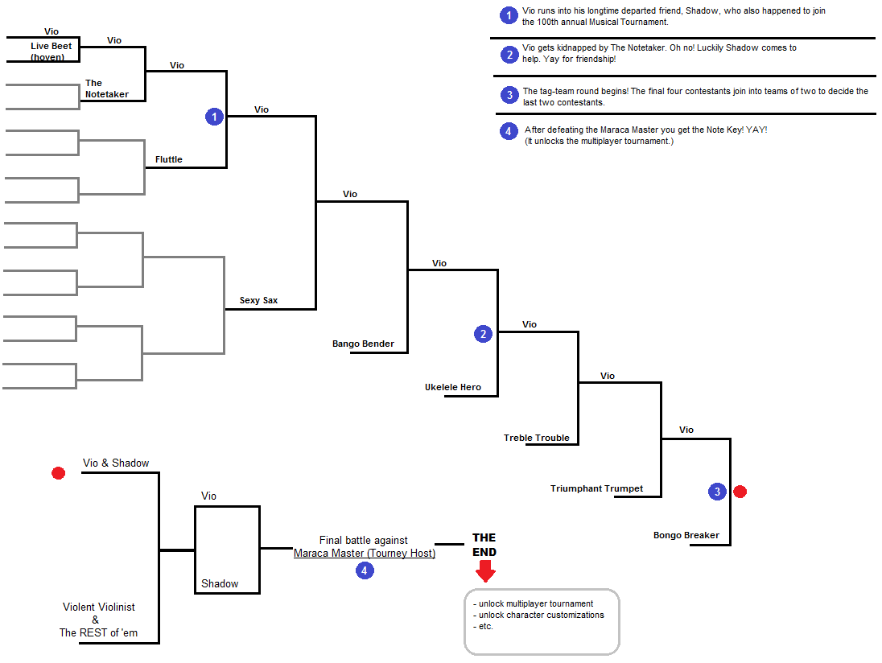

Every year Orkestra, capital of Sinfonia, holds the Music Tournament. This competition attracts countless ambitious and enterprising individuals to gather and brawl head-to-head in musical combat. Those incapacitated and known to forgo will forfeit in ignominy. Meanwhile, those virtuoso who remain strong-willed and ignited will rise to the unparalleled opportunity to compete. The upcoming year, the 100th anniversary of the first competition, promises the victor the legendary Notekey; a relic said to unlock the unknown potential of another world. Who could have what it takes to win--

Vio, a young aspiring violinist, is no doubt one of the best musicians in his small hometown of Denbora. With that fact atop his ego, he wants more; to be *the very best* musician in all the world. Knowing of the favored Music Tournament Vio packs his bags and heads to Orkestra.

Upon arrival who should he see signing up at the gates but his childhood friend long since separated, Shadow. After the encounter, Vio knows what’s at stake. This isn’t just a competitive test of skill, but a battle of the century -- a true show to determine who is *the very best* musician.